MDMGX from ID1
Data Import fails => 594 => Niklas

IH1 100

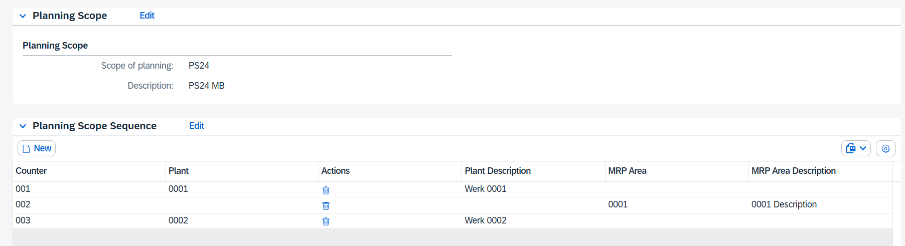

IH1 400
IT Governance (LSA)
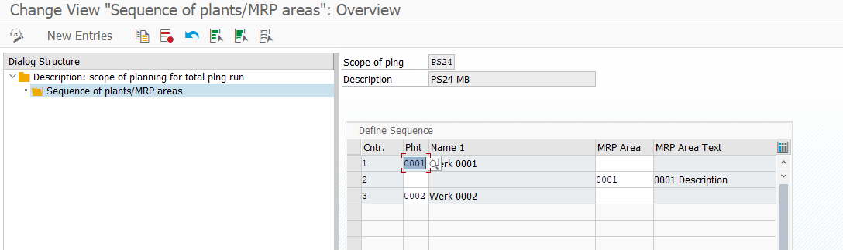

Business Governance (create by Copy)
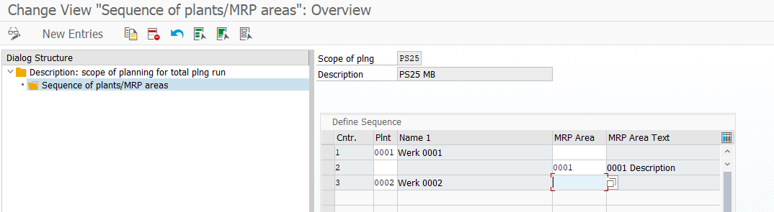

IR1200 (LSA)
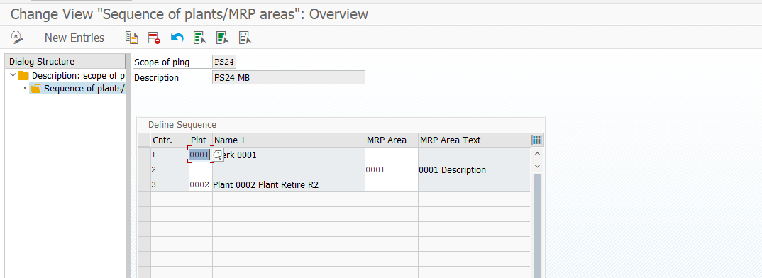

IR2200 (LSA)
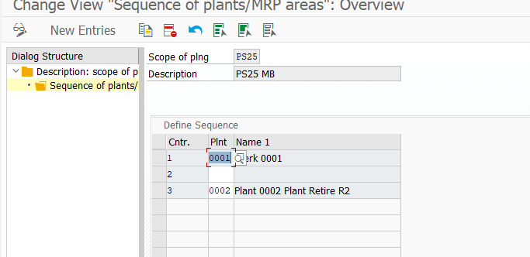

S01 – IDoc cause errors (ok, as there is no planning scope in this release)
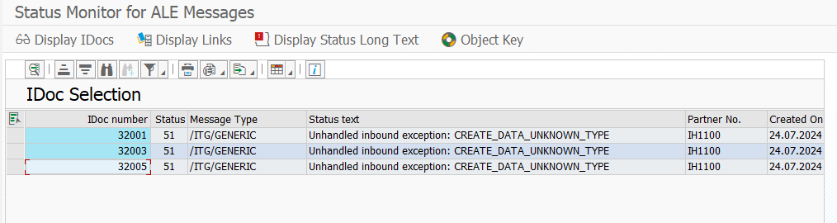

File Download / Upload
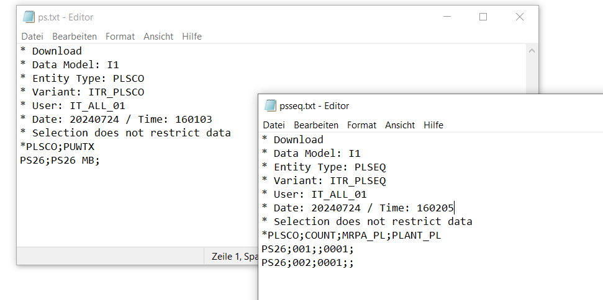
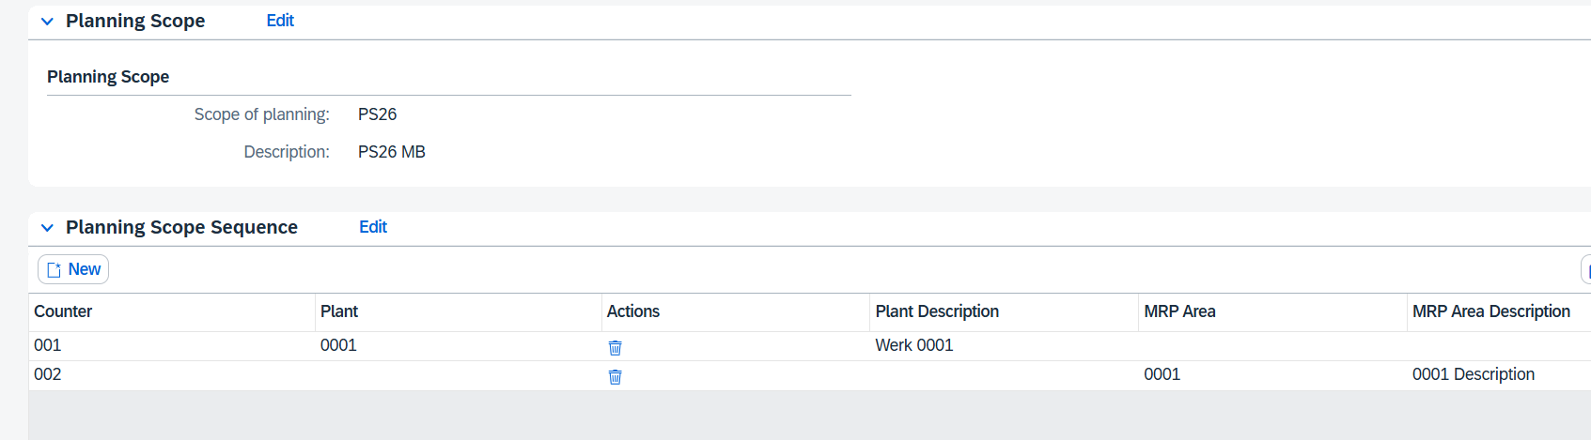

Deletion of entries in the planning sequence
ID1 100

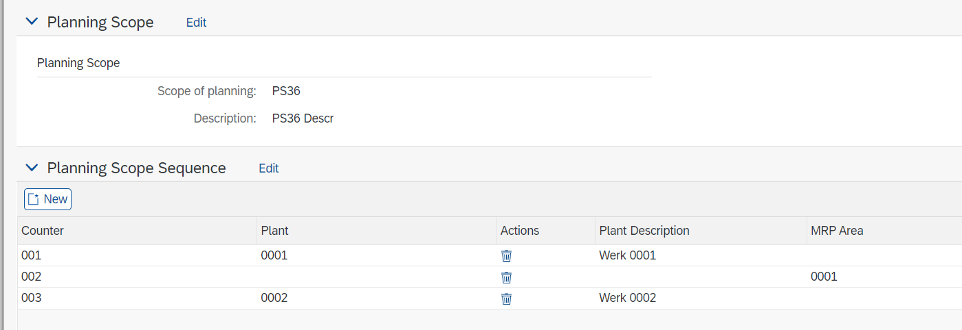

ID1 400
Via LSA
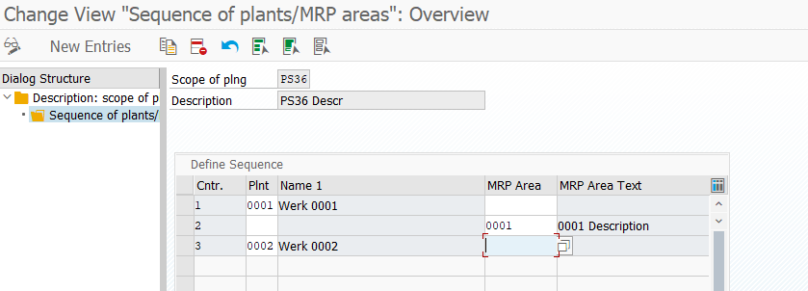

Delete Entry:
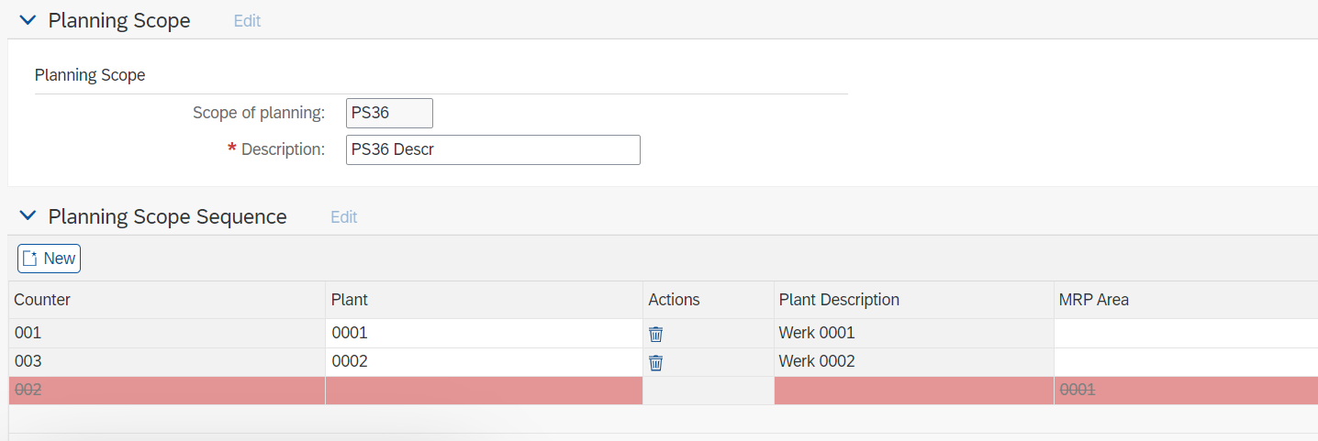

LSA:
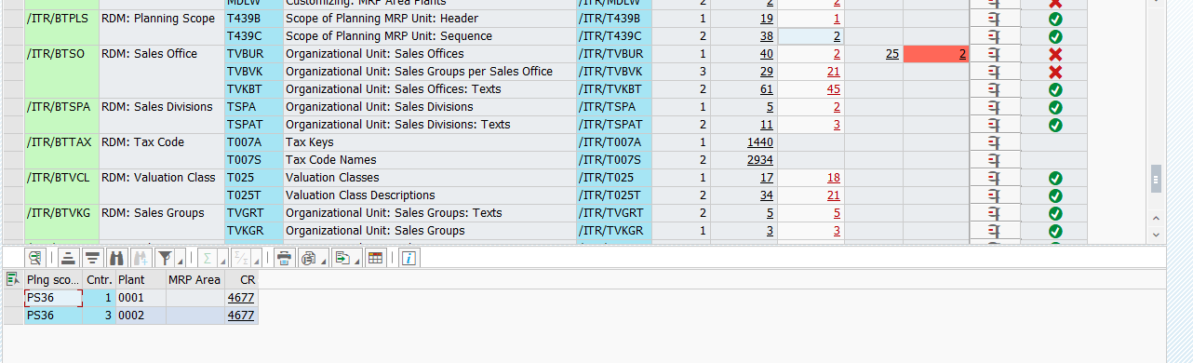

Not deleted
